

Employer toolkit:
resources from Good Thinking


Using this toolkit to support workplace wellbeing

This toolkit contains information about Good Thinking, London's digital mental health and wellbeing service, and how it can help you as an employer. It will support you in raising awareness of the free, personalised advice and NHS-approved apps and resources available through our website to help promote positive mental health and wellbeing across your organisation.

The toolkit includes:

- an introduction to the Good Thinking digital mental health and wellbeing service and how it can support employee wellbeing
- information about and links to useful free mental wellbeing resources for you to share with staff, wellbeing leads and HR teams
- a five-step ‘how to’ guide on how to use Good Thinking in the workplace
- suggested newsletter/bulletin copy to help you raise awareness of Good Thinking within your organisation and signpost to resources
- links to printable and digital assets for you to promote Good Thinking across digital channels and in communal work spaces
- links to our series of workplace wellbeing training videos for employers and employees, focusing on stress, anxiety, low mood and sleep problems.

You can find out more on our website and our dedicated employer pages.

If you have any questions, please contact us.

About Good Thinking

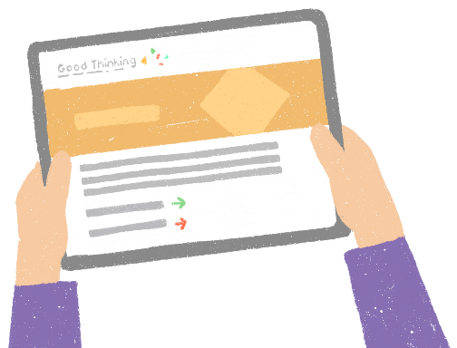
What is Good Thinking and how can it help you support employee wellbeing?

We know it can be time-consuming to find good quality free resources that support your employee wellbeing strategy. If you’re London based, we’re
here to help.

Good Thinking is a digital service which has helped over 800,000 Londoners look after their mental health and wellbeing in a way that works for them. We provide personalised advice, support and resources to help people struggling with:
- stress
- anxiety
- low mood
- sleep
- other mental health concerns such as trauma, bereavement and the impact of the rising cost of living

Our service is:
- free of charge
- NHS-approved
- available 24/7 on any device and completely anonymous
- relevant to organisations in the public, private and not-for-profit sectors
- a great resource to support employee wellbeing programmes and internal communications activities

Stress, anxiety and burnout are common problems in the workplace. The mental health charity, Mind, reports that 1 in 6 UK workers are experiencing mental health problems and, with current pressures from the cost of living crisis, the need to provide support for employees is now more critical than ever. Good Thinking is here to help employers create a safe and supportive workplace in these challenging times.

What resources are available through Good Thinking?

Good Thinking provides a range of resources to help employees improve their mental wellbeing, including:
- free apps (NHS-approved and independently assessed)
- printable workbooks and guides, including a guide designed specifically for employees, to help them support colleagues and team-mates who may be struggling with their mental health
- advice articles that contain tips to boost mental health
- blogs and personal stories
- podcasts, videos and webinars, including a series of workplace wellbeing training videos covering stress, anxiety, low mood and sleep problems.

We’ve worked closely with faith communities across London to create wellbeing advice that aligns with their beliefs (some of these guides are available in several languages).

Five ways you can use Good Thinking to support employee wellbeing

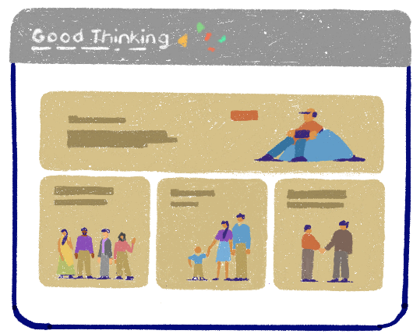
1. Get to know Good Thinking
Spend some time on the Good Thinking website familiarising yourself with our range of information and resources.

Download two or three of the NHS-approved wellbeing apps that we recommend so you can see for yourself how they work.

2. Share this toolkit
Share this toolkit with anyone in your organisation who is involved in health and wellbeing (e.g. HR team, wellbeing leads, line managers, Mental Health First Aiders).

3. Use your internal communications channels and communal spaces
We’ve developed a range of assets and resources that you can use to share the free NHS-approved Good Thinking tools and support with your staff.

These are available to download using the links below:

Graphics that can be used on social media, in newsletters and in other internal communications channels available through our Google Drive folder (you can also find suggested copy on pages 8-10 of this toolkit).

Printable A4 posters, flyers and guides that can be displayed in communal areas:
- Poster 1
- Poster 2
- Poster 3
- Poster 4
- Postcard flyer
- Printable wellbeing guides
- Printable workbooks

Videos:
We’ve uploaded several short videos to YouTube to help you promote the Good Thinking service.

YouTube video links | Description
https://youtu.be/SZoZCyrzuOA | Dr Chantelle Fatania, Consultant in Public Health at Haringey Council, talks about Good Thinking’s range of faith and belief community based resources.
https://youtu.be/6vU8sK0et_A | Professor Kevin Fenton CBE, London Regional Director, OHID, explains what Good Thinking means to Londoners.
https://youtu.be/6vLdFp4yN5M | Dr Chris Streather, London Regional Medical Director, NHSE London, talks about how Good Thinking supports Londoners with positive mental health and resilience.
https://youtu.be/8MmIWKD5Uzs | Dr Phil Moore GP, Mental Health Clinical Co-Director for London explains how Good Thinking can be accessed free of charge, 24/7 for reliable, NHS-approved advice and resources.

DOWNLOAD: Individual videos can also be downloaded through our Google Drive folder.

DOWNLOAD: All the videos listed above are available to download in portrait format for Instagram reels through our Google Drive folder.

Workplace wellbeing training videos:

We’ve also launched a series of workplace wellbeing training videos for employers and employees covering common mental health conditions, such as stress, anxiety, low mood and sleep problems.

YouTube video links | Description
https://youtu.be/D-SFdrDwZiM | Understanding anxiety
https://youtu.be/uimxNnCg5fs | Understanding low mood
https://youtu.be/p-HgNVibPmI | Understanding sleep problems
https://youtu.be/t7ieKrwYzr4 | Understanding stress

4. Incorporate Good Thinking into your wellbeing initiatives

There are lots of ways you can share the Good Thinking resources within your organisation. You could:
- include information about Good Thinking and links to the website in your induction packs for new starters
- link to Good Thinking from your intranet and in any newsletter/bulletin articles about mental health and wellbeing
- provide your Mental Health First Aiders and line managers with information about Good Thinking
- share our guide to Looking out for friends and colleagues at work to support them with talking to colleagues about mental health
- print our Good Thinking wellbeing guides, posters and flyers for use at staff wellbeing events and display them in communal areas
- use our promotional tools (including the graphics and videos from pages 4-5 and copy from pages 8-10) to support mental health awareness campaigns (e.g. World Mental Health Day). Check out Good Thinking’s calendar of mental health awareness days for ideas and inspiration
- tag and refer to Good Thinking in wellbeing-related tweets and LinkedIn posts.
- invite a member of the Good Thinking team to join a staff meeting and share information about the service (contact us via info@good-thinking.uk)

5. Stay up to date with new support and resources

Sign up to our monthly newsletter and follow Good Thinking on social media to stay up to date on new advice and resources available to share with your employees:


goodthinkinguk goodthinkinguk


goodthinkinguk @GoodThinkingUK

Suggested copy for staff newsletters



Boost your mental wellbeing with Good Thinking

Good Thinking is a free, digital mental health and wellbeing service that gives people who live and work in London 24/7 access to tailored advice and NHS-approved resources. There is a range of support available if you’re struggling with stress, anxiety, low mood, sleep or another mental health concern.

With the rising cost of living and other pressures, you or someone you know might be looking for help and support. Good Thinking is on hand, with tailored guidance and recommended resources, as well as free NHS-approved apps, advice, workbooks, podcasts and videos.

Good Thinking can also help you to look out for colleagues and team-mates who may be feeling stressed, anxious or overwhelmed, with a handy guide to starting a positive conversation and creating a safe and supportive space for them to open up and share their concerns.

More than 800,000 Londoners have already benefitted from the Good Thinking service. Visit Good Thinking to find out how it can help you.

Suggested copy for individual Good Thinking resources

You may wish to share information with your employees about a specific Good Thinking resource, such as our selection of free NHS-approved apps, so we have provided copy for a range of our tools individually:

Resource | Copy
General text about Good Thinking | Everyone needs help from time to time.  If you or someone you know is struggling, Good Thinking is available 24/7 with free advice and resources to boost your mental wellbeing.  Visit www.good-thinking.uk for tools to help you tackle stress, anxiety, low mood and poor sleep.
Good Thinking free NHS-approved wellbeing apps | Wellbeing apps can help reduce anxiety, improve sleep, lower stress and boost your mood.  Visit www.good-thinking.uk/apps and explore Good Thinking’s selection of free NHS-approved apps, handpicked by mental health experts and proven to help you maintain positive mental wellbeing.
Good Thinking quick guides to looking out for those around you, including the ‘Looking out for friends and colleagues at work’ guide | As pressures on Londoners grow with the rising cost of living, looking out for yourself and those around you is more important than ever.  Good Thinking’s quick guides are here to support you with checking in on friends, family and colleagues who may be struggling with stress, anxiety and low mood:  www.good-thinking.uk/how-guides/quick-guides-support-others
Good Thinking tailored wellbeing resources and support for faith and belief communities | Londoners want information and support that reflects how they live and what their values are.  Good Thinking works with a diverse range of faith and belief communities across London to provide tailored wellbeing support and advice, including guides, videos and podcasts.  Visit www.good-thinking.uk/faith-and-belief-communities to explore the full range of support.
Good Thinking workbooks | For a more in-depth approach to supporting your own mental health visit www.good-thinking.uk/workbooks and explore Good Thinking’s collection of workbooks.  Covering a broad range of topics such as sleep, anxiety, mindfulness and overcoming low self-esteem, workbooks contain a combination of expert advice, exercises you can do at home and checklists you can use.

Please feel free to share this toolkit amongst your colleagues and networks as far and wide as possible.

