GOOD THINKING COMMS TOOLKIT
Student mental health:
secondary school and further education

Using this document

This toolkit contains information about Good Thinking’s advice and support for young Londoners, and highlights other services and resources which students, parents and carers and education professionals may find helpful. It will support you in raising awareness of the free, personalised advice and NHS-approved apps and resources available through our website to help support positive mental health and wellbeing for students across London.

The toolkit contains information about:

- Printable Good Thinking resources for communal areas
- Links to printable posters, flyers and wellbeing guides and information about how to request professionally printed flyers and A3 posters directly from the Good Thinking team
- Good Thinking’s digital resources for children and young people
- Copy and social media content to share free NHS-approved digital mental wellbeing support and resources to help young people stay mentally healthy
- Going back to school, college or sixth form
- Copy and social media content to signpost Good Thinking’s advice for children and young people who may be worrying about the return to school/college/sixth form
- Helping parents and carers to support children and young people
- Good Thinking’s guide to looking out for children and young people
- Good Thinking’s resources for parents and carers
- Helping education professionals to support children and young people
- Thrive LDN has been working with Nicola Lester Psychological Trauma Consultancy to offer free, online trauma-informed practice training to support those in student-facing or wellbeing support roles
- Transformation Partners in Health and Care’s (TPHC) Schools mental health toolkit

- Looking out for friends
- Good Thinking’s guide to help young people look out for their friends
- TPHC’s and Beat’s resources on spotting early signs of eating disorders

About Good Thinking

What is Good Thinking and how do we support young Londoners?
Good Thinking is a digital service that helps Londoners look after their mental health and wellbeing in a way that works for them. We provide personalised advice, support and resources to help people struggling with:
- Stress
- Anxiety
- Low mood
- Sleep
- Other mental health concerns, such as trauma, bereavement and eating disorders

Our service is:
- Free of charge
- NHS-approved
- Available 24/7 on any device
- Completely anonymous

What resources are available through Good Thinking?
Good Thinking provides a range of resources to help Londoners improve their mental wellbeing, including:
- Free apps (NHS-approved and independently assessed)
- Quick quizzes which give tailored support recommendations
- Printable workbooks and guides
- Advice articles with tips to boost mental health
- Blogs and personal stories
- Podcasts
- Videos and webinars

1. Printable Good Thinking resources

Good Thinking have a range of printable posters, flyers and guides available to download via the Campaign Hub.

If you would like to request professionally printed postcard flyers and/or A3 posters please contact info@good-thinking.uk detailing the number required and postal address.

Flyer and posters:
- Good Thinking flyer
- Good Thinking poster 1 (A4)
- Good Thinking poster 2 (A4)
- Good Thinking poster 3 (A4)
- Good Thinking poster 4 (A4)
- Good Thinking poster 1 (A3)
- Good Thinking poster 2 (A3)

Printable wellbeing guides:
- Five ways to wellbeing for children and young people
- Good Thinking support one pagers for children and young people
- Looking out for your friends

- Good Thinking’s digital resources for children and young people

Copy for newsletters and bulletins

Good Thinking – digital mental health support for young Londoners

Good Thinking, London’s free, NHS-approved digital mental health and wellbeing service, understand that there is no ‘one size fits all’ solution for mental health.

The Good Thinking service helps young Londoners look after their mental wellbeing, providing direct access to a range of online tips, tools and advice to support the four most common mental health conditions; stress, anxiety, low mood and sleep problems, and other mental health concerns such as bereavement and eating disorders.

For more information about the service and to access free NHS-approved support and resources, visit Good Thinking.

-Ends-

Content for social media

Copy for Twitter | Graphic
Young Londoners! Are you feeling stressed, anxious or overwhelmed?  @GoodThinkingUK brings together a selection of the best free, NHS-approved digital #MentalHealth support and resources for children and young people.  Find the best fit for you: https://www.good-thinking.uk/youngpeople | Download graphics here  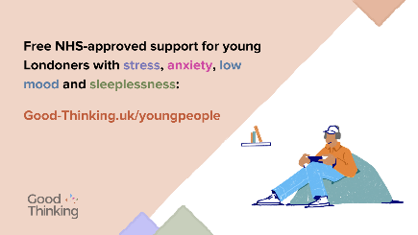
In uncertain times it's normal to feel worried and anxious.  Visit https://www.good-thinking.uk/youngpeople for advice and free NHS-approved apps and resources to help you manage stress, anxiety, low mood and poor sleep. | 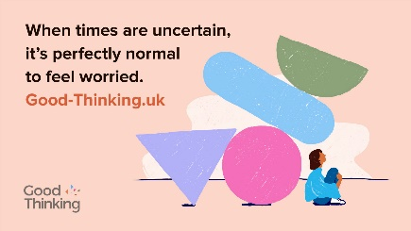
Young Londoners! Are you feeling stressed, anxious or overwhelmed?  @GoodThinkingUK brings together a selection of the best free, NHS-approved digital #MentalHealth support and resources for children and young people.  Find the best fit for you: https://www.good-thinking.uk/youngpeople | 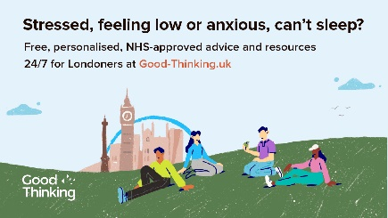
Copy below is for Good Thinking’s Student Mental Health Hub, which contains content and resources suitable for those in further and higher education
@GoodThinkingUK’s Student #MentalHealth Hub has free tips, tools and advice to help you maintain healthy habits and prioritise good mental wellbeing while studying.  Find out more:  👉https://www.good-thinking.uk/students | 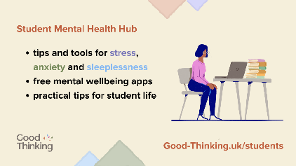

Copy for Instagram | Graphic
Young Londoners! Are you feeling stressed, anxious or overwhelmed?  @goodthinkinguk brings together a selection of the best free, NHS-approved digital #MentalHealth support and resources for children and young people.  You'll find:  👉mental wellbeing advice and resources  👉help and guidance on supporting friends who may be struggling  👉free NHS-approved apps  👉urgent support and mental health helplines  Find the best fit for you: good-thinking.uk/youngpeople | Download graphics here  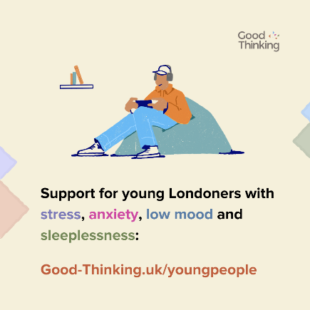
In uncertain times it's normal to feel worried and anxious.  Visit good-thinking.uk/youngpeople for advice and free NHS-approved apps and resources to help you manage stress, anxiety, low mood and poor sleep. | 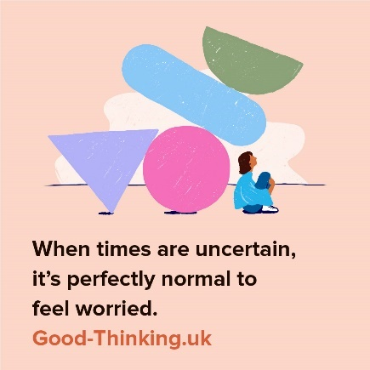
Young Londoners! Are you feeling stressed, anxious or overwhelmed?  @goodthinkinguk brings together a selection of the best free, NHS-approved digital #MentalHealth support and resources for children and young people.  You'll find:  👉mental wellbeing advice and resources  👉help and guidance on supporting friends who may be struggling  👉free NHS-approved apps  👉urgent support and mental health helplines  Find the best fit for you: good-thinking.uk/youngpeople | 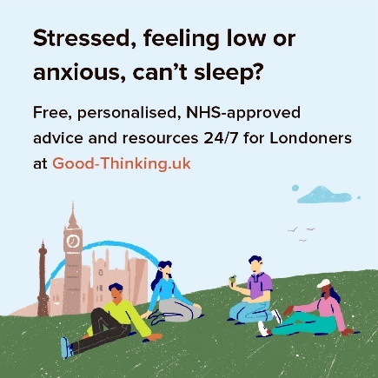
Copy below is for Good Thinking’s Student Mental Health Hub, which contains content and resources suitable for those in further and higher education
@goodthinkinguk’s Student #MentalHealth Hub has free tips, tools and advice to help you maintain healthy habits and prioritise good mental wellbeing while studying.  Find out more:  👉good-thinking.uk/students | 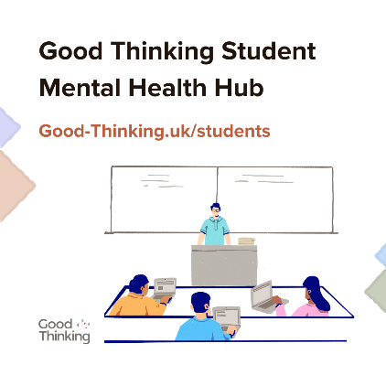

Copy for Facebook / LinkedIn | Graphic
Young Londoners! Are you feeling stressed, anxious or overwhelmed?  @goodthinkinguk brings together a selection of the best free, NHS-approved digital #MentalHealth support and resources for children and young people.  You'll find:  👉mental wellbeing advice and resources  👉help and guidance on supporting friends who may be struggling  👉free NHS-approved apps  👉urgent support and mental health helplines  Find the best fit for you: https://www.good-thinking.uk/youngpeople | Download graphics here
Young Londoners! Are you feeling stressed, anxious or overwhelmed?

@goodthinkinguk brings together a selection of the best free, NHS-approved digital #MentalHealth support and resources for children and young people.

You'll find:
👉mental wellbeing advice and resources
👉help and guidance on supporting friends who may be struggling
👉free NHS-approved apps
👉urgent support and mental health helplines

Find the best fit for you: https://www.good-thinking.uk/youngpeople
Copy below is for Good Thinking’s Student Mental Health Hub, which contains content and resources suitable for those in further and higher education
Balancing student life alongside everyday worries in these challenging times can be tough.  @goodthinkinguk’s Student #MentalHealth Hub brings together the best digital support and resources for #stress, #anxiety, low mood & sleep problems.  You'll find:  👉advice and resources to help you cope with the stresses and challenges of life at university  👉help and guidance on supporting friends who may be struggling  👉practical tips for student life  👉free NHS-approved apps  👉urgent support and mental health helplines  Find the best fit for you: https://www.good-thinking.uk/students | 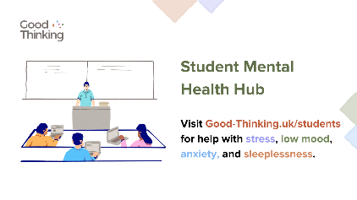

- Going back to school, college or sixth form

Good Thinking’s advice for children and young people going back to school, college or sixth form can be found here.

Copy for newsletters and bulletins

Good Thinking’s wellbeing tips for going back to school

It’s perfectly normal to feel anxious and stressed as a new school year begins. Good Thinking has five top tips to help you focus on what you can control and feel more positive.

Good Thinking is London’s NHS-approved, online mental health and wellbeing platform, providing free advice, tips and tools to help with stress, anxiety, low mood and sleep problems. For more information about the service, visit Good Thinking.

-Ends-

Content for social media

Copy for Twitter | Graphic
It’s perfectly normal to feel anxious and stressed as the new school year begins.  @GoodThinkingUK has top tips to boost your mood and a range of free NHS-approved resources to help you cope if you are feeling overwhelmed.  👉https://www.good-thinking.uk/advice/five-wellbeing-tips-back-to-school | Download graphics here  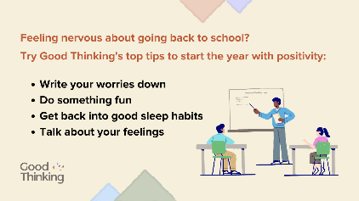
The beginning of a new school year is exciting but it can also be nerve-wracking.

Explore @GoodThinkingUK’s top tips to help you settle back into a routine and start the year with positivity.

👉https://www.good-thinking.uk/advice/five-wellbeing-tips-back-to-school

Copy for Instagram | Graphic
It’s perfectly normal to feel anxious and stressed as the new school year begins.  @goodthinkinguk has top tips to boost your mood and a range of free NHS-approved wellbeing resources to help you cope if you are feeling overwhelmed.  👉good-thinking.uk/advice/five-wellbeing-tips-back-to-school | Download graphics here  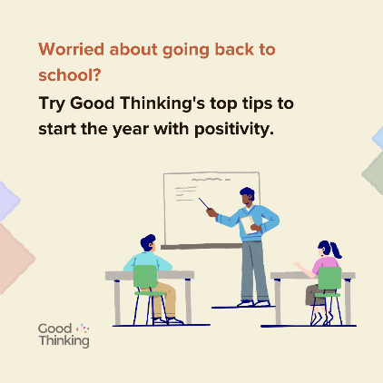
The beginning of a new school year is exciting but it can also be nerve-wracking.

Explore @goodthinkinguk’s top tips to help you settle back into a routine and start the year with positivity.

👉good-thinking.uk/advice/five-wellbeing-tips-back-to-school

Copy for Facebook / LinkedIn | Graphic
It’s perfectly normal to feel anxious and stressed as the new school year begins.  @goodthinkinguk has top tips to boost your mood and a range of free NHS-approved wellbeing resources to help you cope if you are feeling overwhelmed.  👉https://www.good-thinking.uk/advice/five-wellbeing-tips-back-to-school | Download graphics here
The beginning of a new school year is exciting but it can also be nerve-wracking.

Explore @goodthinkinguk’s top tips to help you settle back into a routine and start the year with positivity.

👉https://www.good-thinking.uk/advice/five-wellbeing-tips-back-to-school

4. Helping parents and carers to support children and young people

Good Thinking has a range of support and resources for parents and carers to help them support children and young people with maintaining positive mental health, including a quick guide to looking out for children and young people.

Content for social media

Copy for Twitter | Graphic
Starting a conversation about #MentalHealth when you are concerned about your child can be tough.  So, we've created this practical guide to help you check in regularly and see how they are.  Help them get the support they need with @GoodThinkingUK:  https://goodthinking-strapi.s3.eu-west-2.amazonaws.com/Parents_and_carers_looking_out_for_children_and_young_people_guide_ea4aec98af.pdf | Download graphics here  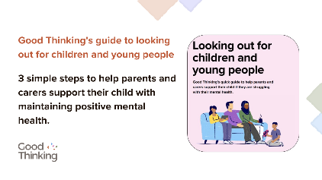
@GoodThinkingUK has a range of dedicated resources for parents and carers.  If your child is stressed, anxious or feeling down about the new school year, there is help and support available, including free NHS-approved wellbeing apps:  https://www.good-thinking.uk/parents-and-carers | 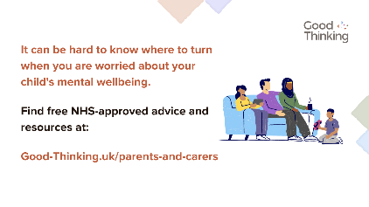

Copy for Instagram | Graphic
Starting a conversation about #MentalHealth when you are concerned about your child can be tough.  So, we've created this practical guide to help you check in regularly and see how they are.  Help them get the support they need with @goodthinkinguk – copy and paste the link below into your browser:  https://goodthinking-strapi.s3.eu-west-2.amazonaws.com/Parents_and_carers_looking_out_for_children_and_young_people_guide_ea4aec98af.pdf | Download graphics here  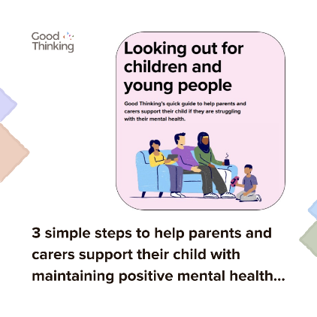
@goodthinkinguk has a range of dedicated resources for parents and carers.  If your child is stressed, anxious or feeling down about the new school year, there is help and support available, including free NHS-approved wellbeing apps:  https://www.good-thinking.uk/parents-and-carers | 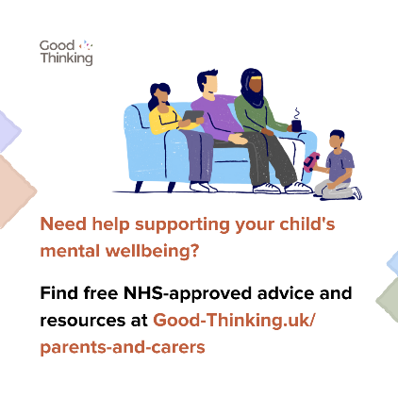

Copy for Facebook / LinkedIn | Graphic
Starting a conversation about #MentalHealth when you are concerned about your child can be tough.  So, we've created this practical guide to help you check in regularly and see how they are.  Help them get the support they need with @goodthinkinguk – copy and paste the link below into your browser:  https://goodthinking-strapi.s3.eu-west-2.amazonaws.com/Parents_and_carers_looking_out_for_children_and_young_people_guide_ea4aec98af.pdf | Download graphics here
@goodthinkinguk has a range of dedicated resources for parents and carers.

If your child is stressed, anxious or feeling down about the new school year, there is help and support available, including free NHS-approved wellbeing apps:

👉https://www.good-thinking.uk/parents-and-carers

5. Helping education professionals to support children and young people

Content for social media
Transformation Partners in Health and Care’s (TPHC) Schools mental health toolkit:

Copy for Twitter | Graphic
Getting back to school or college can be a worrying time for young people.  @_TPHC’s school’s #mentalhealth toolkit gathers advice and resources to help young people look after their mental wellbeing.  Browse the toolkit here:  https://www.transformationpartnersinhealthandcare.nhs.uk/resource/schools-mental-health-toolkit/ | 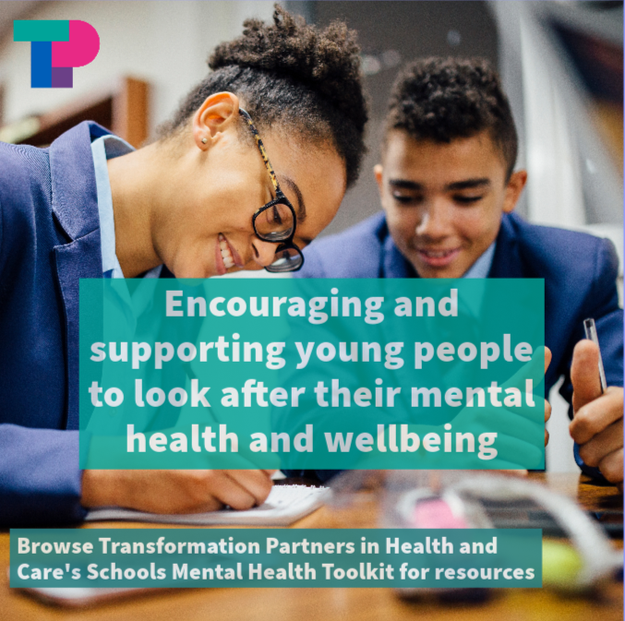  Download here

Copy for Instagram | Graphic
Getting back to school or college can be a worrying time for young people.  Search ‘Schools Mental Health Toolkit’ to browse a digital toolkit on #mentalhealth and wellbeing, which has been put together by @tphc22 for young people, parents and carers, and education professionals. | Download here

Copy for Facebook / LinkedIn | Graphic
Getting back to school or college can be a worrying time for young people.  Transformation Partners in Health and Care’s schools #mentalhealth toolkit gathers advice and resources on a number of topics, including stress, anxiety, and crisis support, to help young people look after their mental health and wellbeing.  Browse the toolkit’s curated hubs for children and young people, parents and carers, and education professionals here:  https://www.transformationpartnersinhealthandcare.nhs.uk/resource/schools-mental-health-toolkit/ | Download here.

Thrive LDN’s Trauma-informed training for education professionals

Thrive LDN has been working with Nicola Lester Psychological Trauma Consultancy to offer free, online trauma-informed practice training to support those in student-facing and wellbeing support roles. The training and supporting resources are available here.

Copy for Twitter | Graphic
#TraumaInformed training: @ThriveLDN has been working with @NicolaLester10 to offer free, pre-recorded online trauma-informed practice training to support individuals and organisations.  You can access the training (at Bronze, Silver & Gold levels) and supporting resources at www.thriveldn.co.uk/trauma-informed | Download all digital assets.  Video:  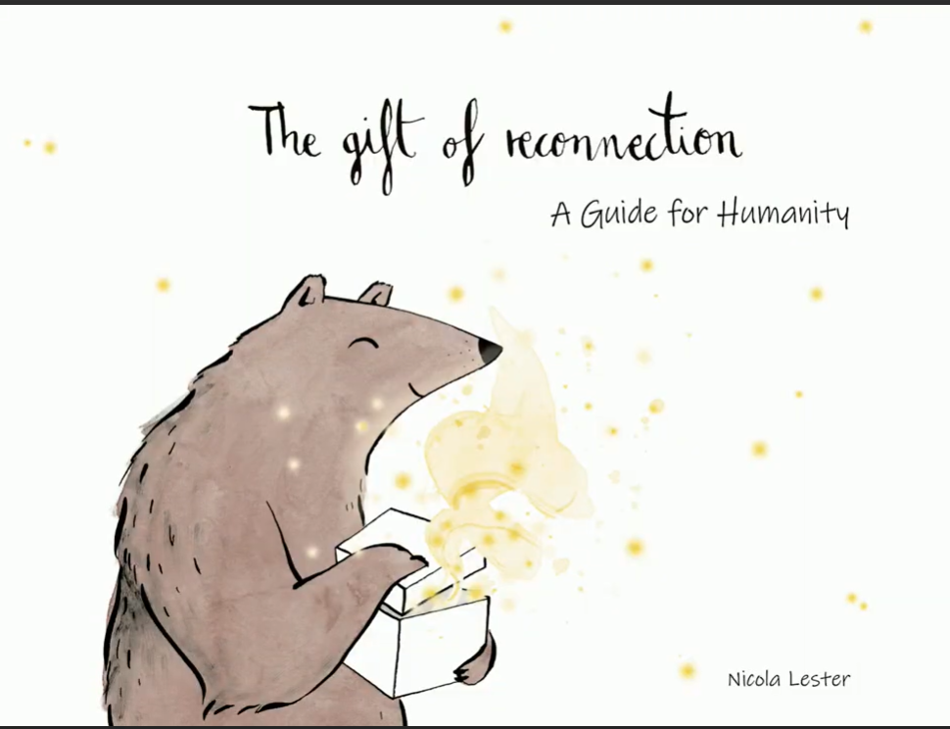  Static:  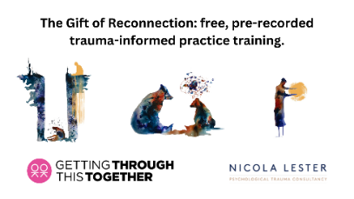
Interested in becoming more trauma aware?

Take @ThriveLDN and Nicola Lester’s free, online training and get certified at Bronze, Silver and Gold level.

You can access the training and supporting resources at www.thriveldn.co.uk/trauma-informed

#ThroughTogether
Did you know for just 30 minutes a week you could become certified as trauma aware in 2 months?

@ThriveLDN has partnered with @NicolaLester10 to offer free trauma-informed practice training, which can be accessed online as pre-recorded videos.

Sign up today at www.thriveldn.co.uk/trauma-informed

Copy for Instagram | Graphic
How trauma aware are you?  @ThriveLDN has partnered with Nicola Lester Psychological Trauma Consultancy to offer free, pre-recorded online trauma-informed practice training to support individuals and organisations.  The training is offered across three levels (Bronze, Silver and Gold) with the opportunity to move up to the next level at each stage.  At each level, participants will receive a certificate of completion and certified badge which can be used to demonstrate their knowledge and trauma informed training status.  Training is free to complete and can be accessed on the @ThriveLDN website: thriveldn.co.uk/trauma-informed  Or search the link in their bio.  #TraumaInformed  #MentalHealthTraining  #ThroughTogether | Download all digital assets.  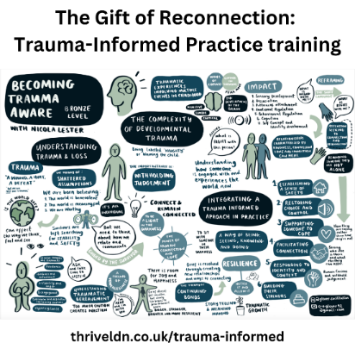  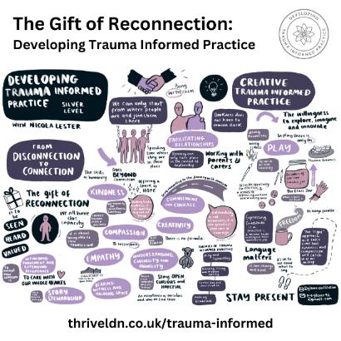  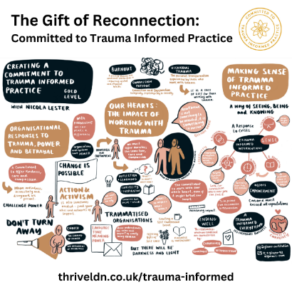
Trauma is a normal reaction to an abnormal situation, and it affects everything – how we think, learn, remember, feel about ourselves and others, and the way we make sense of the world.

Becoming trauma aware enables us to support those who may be struggling or experiencing challenges.

Thrive LDN has partnered with Nicola Lester Psychological Trauma Consultancy to offer free, pre-recorded trauma-informed practice training across three levels (Bronze, Silver and Gold).

At each level, participants receive a certificate of completion and certified badge.

Training is free to complete and can be accessed on the @ThriveLDN website: thriveldn.co.uk/trauma-informed

Or search the link in their bio.

#TraumaInformed
#MentalHealthTraining
#ThroughTogether

Copy for Facebook / LinkedIn | Graphic
How trauma aware are you?  Thrive LDN has partnered with Nicola Lester Psychological Trauma Consultancy to offer free, pre-recorded online trauma-informed practice training to support individuals and organisations.  The training is offered across three levels (Bronze, Silver and Gold) with the opportunity to move up to the next level at each stage.  At each level, participants will receive a certificate of completion and certified badge which can be used to demonstrate their knowledge and trauma informed training status.  Training is free to complete and can be accessed on the @ThriveLDN website:  www.thriveldn.co.uk/trauma-informed | Download all digital assets.  Video:  Static:
How trauma aware is your organisation?

Trauma is a normal reaction to an abnormal situation, and it affects everything – how we think, learn, remember, feel about ourselves and others, and the way we make sense of the world.

As a result, it is increasingly important that we are able to adopt a trauma-informed approach through our work to support individuals or communities who have experienced trauma.

Thrive LDN has partnered with Nicola Lester Psychological Trauma Consultancy to offer free, online, trauma-informed training.

For just 20-30 minutes a week, participants can become certified as fully trauma aware in just 8 weeks.

Training can be completed as a team or individually.

Find out more and sign up at www.thriveldn.co.uk/trauma-informed

- Looking out for friends

The resources below are designed to support people in looking out for the signs and symptoms of mental ill health, and other conditions such as eating disorders, that friends and loved ones may show.

Content for social media
Good Thinking’s quick guide to looking out for friends:

Copy for Twitter | Graphic
Follow @GoodThinkingUK’s simple steps to support friends who are anxious about going back to school, college or uni.  1⃣ Spot the signs and symptoms of mental ill health  2⃣ Check in and let them know you care  3⃣ Help them to get the support they need  👉https://goodthinking-strapi.s3.eu-west-2.amazonaws.com/Young_people_looking_out_for_your_friends_guide_3870dbfa35.pdf | Download graphics here  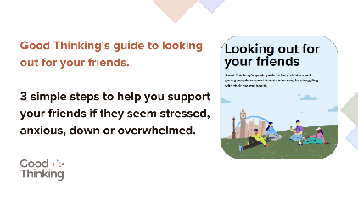
Everyone needs help from time to time.  If you or someone you know is struggling, @GoodThinkingUK is available 24/7 with free advice and resources to boost your mental wellbeing.  Visit www.good-thinking.uk for tools to help you tackle stress, anxiety, low mood and poor sleep. | 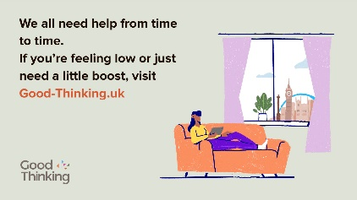

Copy for Instagram | Graphic
Follow @goodthinkinguk’s simple steps to support friends who are anxious about going back to school, college or uni.  1⃣ Spot the signs and symptoms of mental ill health  2⃣ Check in and let them know you care  3⃣ Help them to get the support they need  👉https://goodthinking-strapi.s3.eu-west-2.amazonaws.com/Young_people_looking_out_for_your_friends_guide_3870dbfa35.pdf | Download graphics here  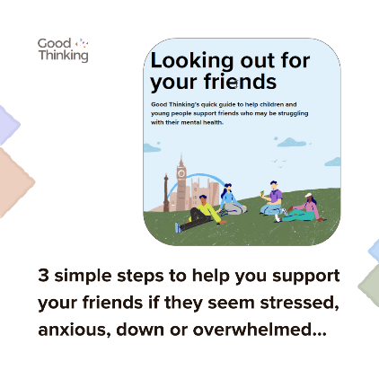
Everyone needs help from time to time.  If you or someone you know is struggling, @goodthinkinguk is available 24/7 with free, personalised advice and resources to boost your mental wellbeing.  Visit www.good-thinking.uk for tools to help you tackle stress, anxiety, low mood and poor sleep.  Or find details in @goodthinkinguk bio. | 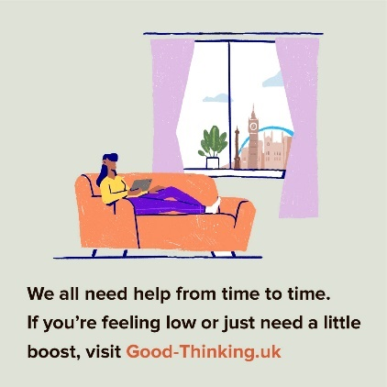

Copy for Facebook / LinkedIn | Graphic
Follow @goodthinkinguk’s simple steps to support friends who are anxious about going back to school, college or uni.  1⃣ Spot the signs and symptoms of mental ill health  2⃣ Check in and let them know you care  3⃣ Help them to get the support they need  👉https://goodthinking-strapi.s3.eu-west-2.amazonaws.com/Young_people_looking_out_for_your_friends_guide_3870dbfa35.pdf | Download graphics here
Everyone needs help from time to time.

If you or someone you know is struggling, Good Thinking is available 24/7 with free, personalised advice and resources to boost your mental wellbeing.

Visit www.good-thinking.uk for tools to help you tackle stress, anxiety, low mood and poor sleep.

Recognising the signs of disordered eating
Transformation Partners in Health and Care (TPHC) has worked with a number of partners to produce practical guidelines to help loved ones and professionals working with children and young people to recognise the signs of an eating disorder or disordered eating.

These signs may or may not be linked to a person’s weight or appearance so it’s important not to make any assumptions. Getting help early can help prevent a condition from worsening, please speak to a GP for advice if you are concerned about any changes.

Changes or restrictions in eating patterns should be taken seriously, but try not to focus solely on eating – have you noticed any other changes in behaviour? Find resources and links to further support and advice on eating disorders and disordered eating here.

Copy for Twitter | Graphic
Changes in eating patterns can be caused by many factors. If you spot changes in someone’s eating, try not to assume it’s an eating disorder and encourage them to speak to a GP for support.  Find #eatingdisorders resources from @_TPHC:  www.transformationpartnersinhealthandcare.nhs.uk/eating-disorders-resources/ | 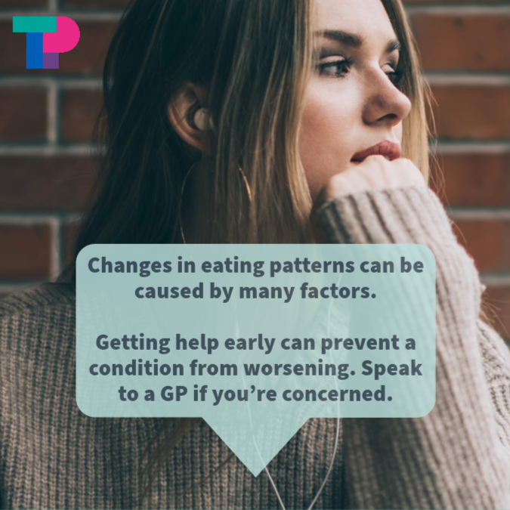
There are 6 signs that someone may be developing an eating disorder.  Getting help early can help prevent a condition from worsening. Find more information and resources on eating disorders from @_TPHC at:  www.transformationpartnersinhealthandcare.nhs.uk/eating-disorders-resources/ | Link to video: https://youtu.be/AiThbk7CYHI  Or download Reel/TikTok here

Copy for Instagram | Graphic
Post:
Changes in eating patterns can be caused by many factors. If you spot changes in someone’s eating, try not to assume it’s an eating disorder and encourage them to speak to a GP for support.
Find more information and resources on #eatingdisorders from @tphc22 and @beatedsupport
Reel:  There are 6 signs that someone may be developing an eating disorder.  Getting help early can help prevent a condition from worsening.  Find more information and resources on #eatingdisorders from @tphc22 and @beatedsupport | Link to full video: https://youtu.be/AiThbk7CYHI  Or download Reel/TikTok here

Copy for Facebook / LinkedIn | Graphic
Post:
Changes in eating patterns can be caused by many factors. If you spot changes in someone’s eating, try not to assume it’s an eating disorder and encourage them to speak to a GP for support.
See Transformation Partners in Health and Care’s resources on children and young people’s #eatingdisorders for more information:

www.transformationpartnersinhealthandcare.nhs.uk/eating-disorders-resources/

Further support and information can be found by visiting: /www.beateatingdisorders.org.uk/
There are 6 signs that someone may be developing an eating disorder.  Getting help early can help prevent a condition from worsening.  See Transformation Partners in Health and Care’s resources on children and young people’s #eatingdisorders for more information:  www.transformationpartnersinhealthandcare.nhs.uk/eating-disorders-resources/  Further support and information can be found by visiting: /www.beateatingdisorders.org.uk/ | Link to video: https://youtu.be/AiThbk7CYHI  Or download Reel/TikTok here

Your support in sharing the Good Thinking service is greatly appreciated.

Please feel free to share this toolkit amongst your colleagues and networks as far and wide as possible.

